|  |
| --- |
| Hailey Bighorn |
| Between |
|  |

**Section 1: Overview**

1. Game Concept

A young man, living alone in a busy city, spends his free time playing an old game he found at a resale store. The game in question is a side scrolling adventure game, and he’s been stuck in the same endless dungeon for months. The game has an average plot, something about saving a princess trapped by an evil monster. The young man has been playing it for so long, that the plot details are sort of fuzzy at this point. One night while backtracking in the dungeon, the young man notices a small crack in the pixelated background that he’s never seen before. He manages to get his player to break is open and new part of the dungeon opens, and a very similar crack appears on his apartment door.

Gameplay would be split between the real world and game world. It will include side scrolling, platformer elements, along with fairly simple hack and slash combat, with minimal life simulation elements in the ‘real world’ and RPG elements in the ‘game world’. In the ‘real world’ you can buy items that will help on your journey as well as talk to NPCs to figure out how to help their game counterparts. They may also ask you to help with small tasks. On the other side of things, in the ‘game world’, NPCs there will give more insight to what’s troubling their counterparts in the real world, helping you figure out how to aid those you care about.

Essentially, there is a balance between these two worlds that the player must navigate. There is a cause and effect, a balance that you can reach. Fighting physical monsters in the game might help someone get rid of some mental ones. The characters are more important than the combat. They are the focus and the reason you’re fighting in the first place.

1. Game Genre: Adventure, platformer, life simulation
2. Target Audience: Primarily older teens to young adults. Around the 18 to 25 demographic.
3. Game Flow Summary:

Both through framing interface and the game itself. The player would have very basic movement in the ‘real world’. Simply moving in their side scrolling location while being able to interact with a few elements. In the ‘game world’, they will be able to run quickly and jump high, double jumping other elements to explore thoroughly. While there will be combat, enemies are more like small hurdles. Exploration is the key.

1. Look and Feel:

Since this game is split into two different worlds, my initial thought is to have two different art styles. The ‘game world’ would be built in pixel art, either 16bit or 32bit. On the other hand, the 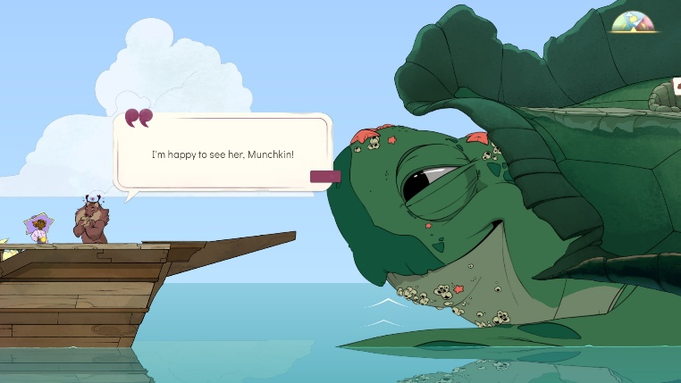‘real world’ would be much more detailed, in vector art. I want the two to be completely different in appearance, only having the barest similarities. For the ‘real world’ aspects, something like Spiritfarer or Gris are good examples. An almost hand draw quality to it. The ‘game world’ would be gloomier, rougher. Mostly dark since it takes place in a damp dungeon.

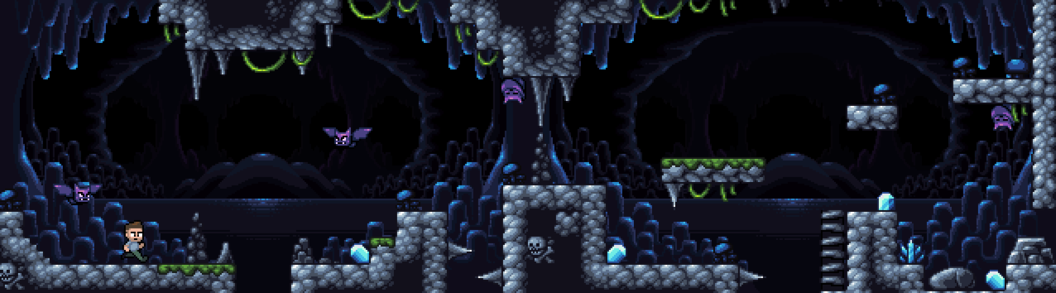

1. Project scope:

Since this would take place between two, very stylistically different places, this is a bit complicated. Not on par with say, a big budget AAA game, but more along the lines of a well-funded indie game.

The Real World would have two locations where the player can move and interact. The main characters (Henry) apartment and the street in the neighborhood he lives in. His apartment would be where he can access the Game World. Outside on the street is where he can pick up and progress quests along with buying items that can benefit him in the other world. Inside the Game World, the only location would be the dungeon, but there would be seven levels of said dungeon that change in small ways the more you progress.

There will be many NPCs, split between the two worlds. However, with the way this game is split, half of those characters are, essentially, doppelgangers of one another. They would have the same basic look, with only the clothing changing from world to world.

**Section 2: Gameplay and Mechanics**

1. Gameplay

First, the mission is to beat the game Henry has been casually playing for months. But when the two worlds suddenly collide your objective changes to helping those around you and figuring out why this happened. Each level of the dungeon will have different enemies roaming around and items to find. You will have to find people on each level as well. The new dungeon levels open after you’ve helped those on the current level. The focus is on the relationships, on the people. The main goal isn’t to get to the center of the dungeon anymore. It’s to get you and the people around you out of it.

Each level will have a boss as well, and that boss will be a representation of something the main character needs to overcome/confront. The puzzles all revolve around the people you help. You must travel between both worlds to talk to people and learn what’s ailing them and figure out how to solve it. The solutions won’t just be in the Game World either. Sometimes they will occur in the Real World too.

I want the player to find value and interest in both sides of the game. In both the adventuring dungeon and in the quieter neighborhood. Switching between both worlds is easy and it’s beneficial to do so. This will be a story driven game, so it is structured, but there is freedom in what the player chooses to do first on each level.

1. Mechanics:

The mechanics of this game will be split in two. In one half, there will be a life simulator in the Real World. You play as the main character and can-do things you would do in real like. Interacting with the environment and its inhabitants is key here. Things would be very simple here, and sticking to the side scrolling aspect that we’ll see later in the Game World. The character will be able to give two to three dialogue options in certain situations and can also eat, drink, and go shopping. Talking and interacting with NPCs is the main way to ‘open’ up this part and give you more things to benefit from. This would be the most limited portion of the game in a way.

In the Game World, the player has much more freedom. Sticking to a side scroller, they can move quickly and freely in the dungeon environment. While there is fighting and running and jumping here, it is still bound by the rule that talking to the NPCs unlocks more in the world. They are the key to progressing in the levels, as they can give you items to get passed obstacles or open passages.

1. Actions:

Switches and Buttons?

Yes and yes. This will happen in the dungeon exclusively.

Picking Up, Carrying and Dropping?

Yes to all three. In both worlds.

Talking?

Yes and a lot of it. Talking to people is how you will solve puzzles. Player dialogue options don’t change the story, but will change NPC response.

Reading?

Yes, dialogue will be read. There will be in game texts as well such as text messages, notes, books.

Combat ?

Yes to combat. Player will have a sword for slash damage (three combo hit) and a shield to block ranged attacks and cast a ranged attack as well (hold shield button to charge for a large ranged attack). Jumping to dodge is an option as well as ducking to avoid attacks as well.

**Section 3: Story, Setting and Character**

1. Back story

Normal young adult guy, living away from home after finishing his degree. He is stuck in between a few decisions for his future and can’t seem to make up his mind and trying to find the time to grieve losing his grandfather, whom he originally lived with while in school. Does he keep working at his boring job that pays his bills? Does he go back to school to get the education he wants and suffer student loans? Does he finally let himself fall in love with the girl he cares for, even though she might move away soon? Why does he feel so disconnected from all these decisions? He doesn’t know what to do, and so, he does nothing. Just repeating the same day, over and over. In his spare time, he started playing video games again and found an old game from a resell store across town. He’s been playing it off and on for a month but got stuck in a dungeon and can’t get out. That is, until he tries something new.

1. Encounters

Most encounters will be talking to characters that you meet both in the ‘real world’ and the ‘game world’. There will be some communication between characters via text messages and written notes in both worlds.

1. Level Walkthrough

Each level in the dungeon will grow larger and more intricate as the game goes on. The gate to the next level will be easy to find if you run from point a to point b, but it won’t be unlockable until you complete the goals. Hidden in each level is a set amount of NPC’s you have to find and aid in their own quests. There will be hidden passages ways the player has to find/reach to locate these people. Items will also be hidden about will enemies scattered around to make traversing the dungeon a little more challenging.

1. HUD - What controls

Will have heath bar and magic bar in the bottom left. Magic is drained by the ranged attacks your shield makes, although it does regenerate rather quickly. Level number indicated on the top of heath/magic bar.



1. Menus

Phone screen menu in both worlds. One vector art, one pixel.

**Section 4: Game Art**

1. Concept Art – Main character and enemy basics complied in this zip. Enemies would be done in pixel art, while the main character would have a more cartoon/detail appearance.
2. Style Guide – Game World much darker/gloomier. Sticks to darker colors, almost like the world is in a sepia tone filter. On the other hand, the Real World would be very colorful by comparison. Softer, smoother lines. Warmer colors.
3. Characters – Will be split into two different art styles depending on where they came from. They will be brighter than the environment so that they don’t blend in.
4. Environments – The Real World would be busy, filled with color and details to look at. The Game world would be bleak by comparison, with mostly darkness to look at and slabs of stone.
5. Equipment – Would also be brighter to stand out. Slightly better resolution in the Game World to stand out. Like their beacons in the darkness.
6. Cut scenes – Not much change between normal gameplays.